Project Design Phase-II
Technology Stack (Architecture & Stack)
Date | March 2026
Team ID | 69bf7f20c1eab70902258904
Project Name | Automating Data Import and Relationship Mapping Using Import Sets & Dot Walking
Maximum Marks | 2 Marks

Technical Architecture
The system automates data import into ServiceNow using Import Sets and Transform Maps. Uploaded data files are processed, transformed, and mapped into target tables. Dot walking is used to establish relationships between related tables.
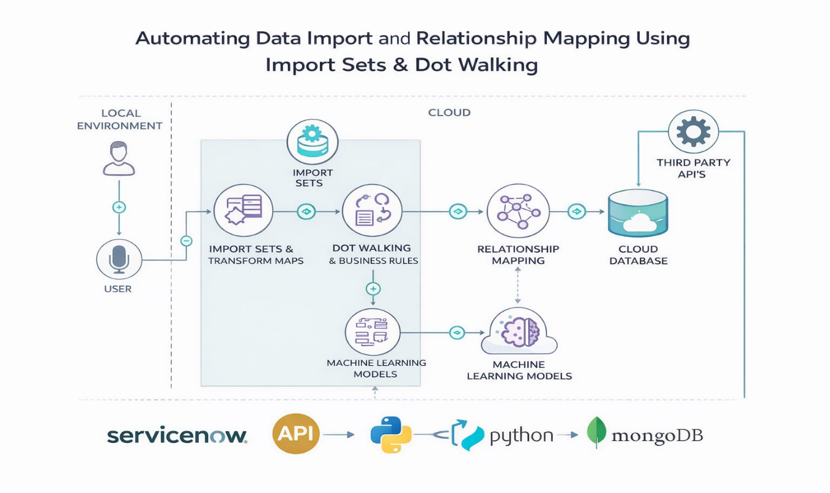

S.No | Component | Description | Technology
1 | User Interface | Interface for uploading data and viewing mapped relationships | HTML, CSS, JavaScript, ServiceNow UI
2 | Application Logic-1 | Import Set creation and data loading process | ServiceNow Import Sets
3 | Application Logic-2 | Transform Map logic for data transformation | ServiceNow Transform Maps
4 | Application Logic-3 | Relationship mapping using dot walking | ServiceNow Scripting (Glide Record, Dot Walking)
5 | Database | Stores imported and transformed data | ServiceNow Tables
6 | Cloud Database | Cloud-based data storage and management | ServiceNow Cloud Platform
7 | File Storage | Stores uploaded files (CSV, Excel) | ServiceNow Attachment System
8 | External API-1 | Fetch external data if required | REST API Integration
9 | External API-2 | Third-party system integration | SOAP / REST APIs
10 | Machine Learning Model | (Optional) Data validation or prediction | Not Applicable / Basic Rule Engine

Table-2: Application Characteristics
S.No | Characteristics | Description | Technology
1 | Open-Source Frameworks | Frameworks used for development | ServiceNow Platform (Low-code), JavaScript
2 | Security Implementations | Access control and data protection | Role-Based Access Control (RBAC), ACL, Encryption, OWASP Practices

